**lntraday Top Down Analysis - 4 Hour to 5 Minute**

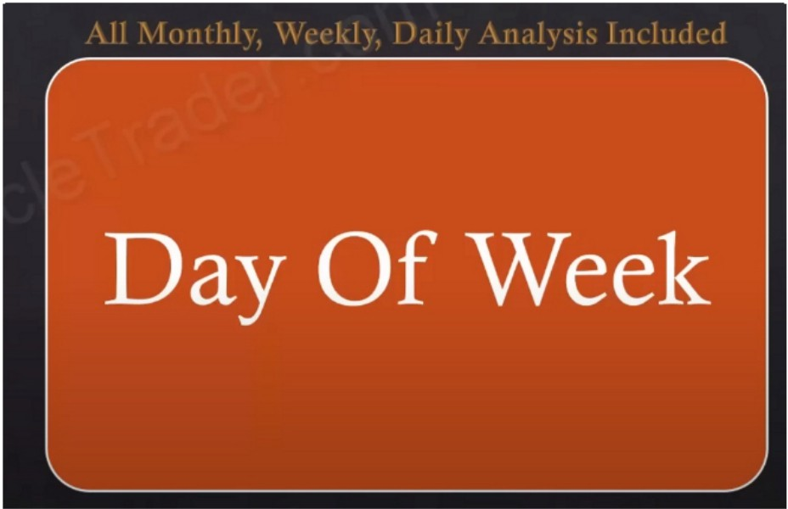.71 1 backlink

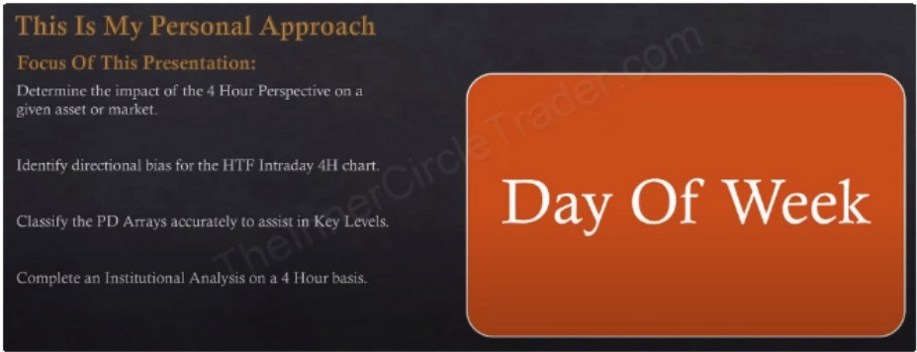

First thing is day of the week and which profiles and templates may exist for that particular day

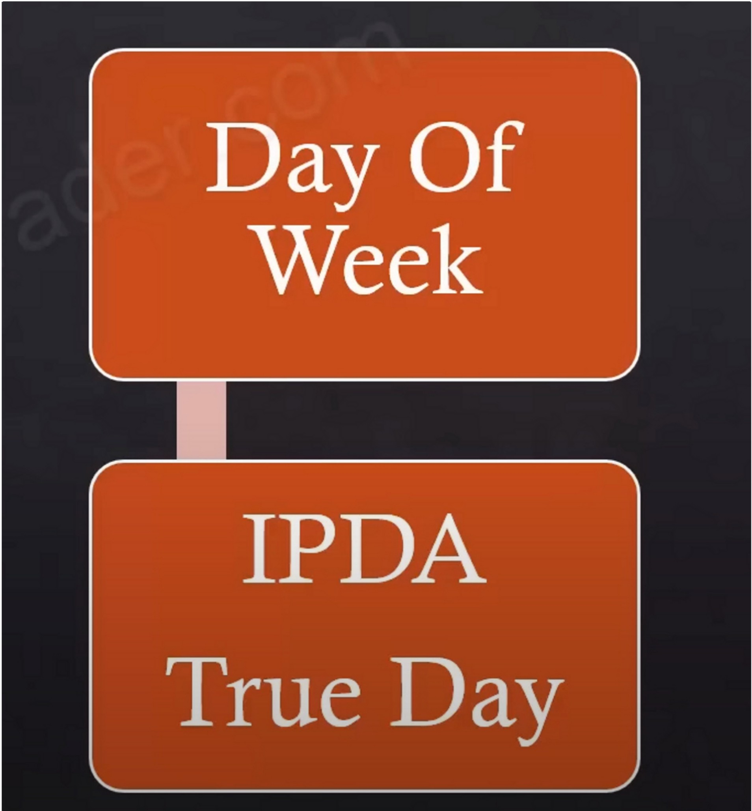

Only focus on setups within the true day

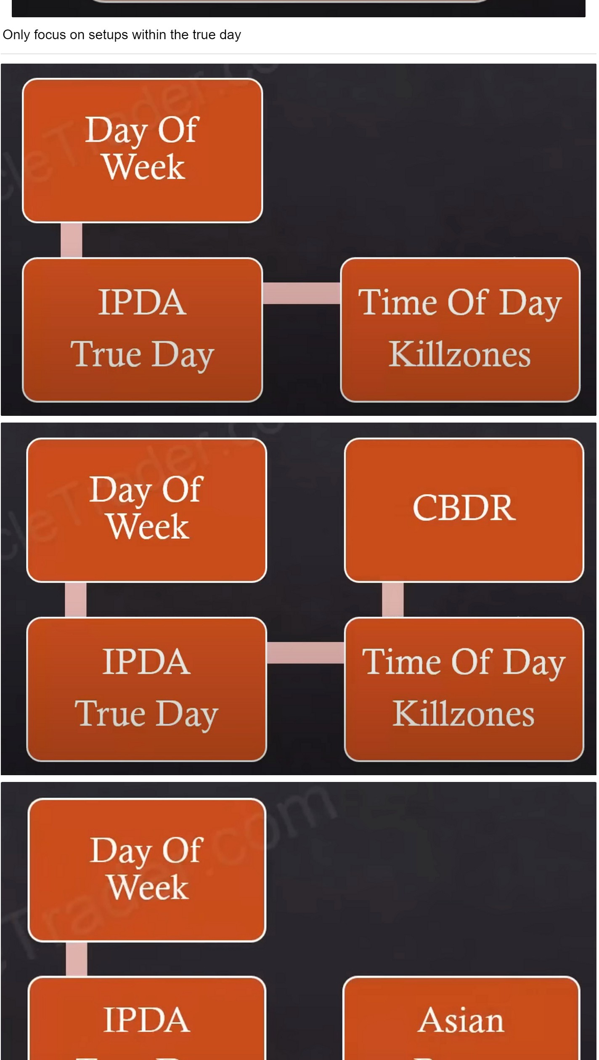

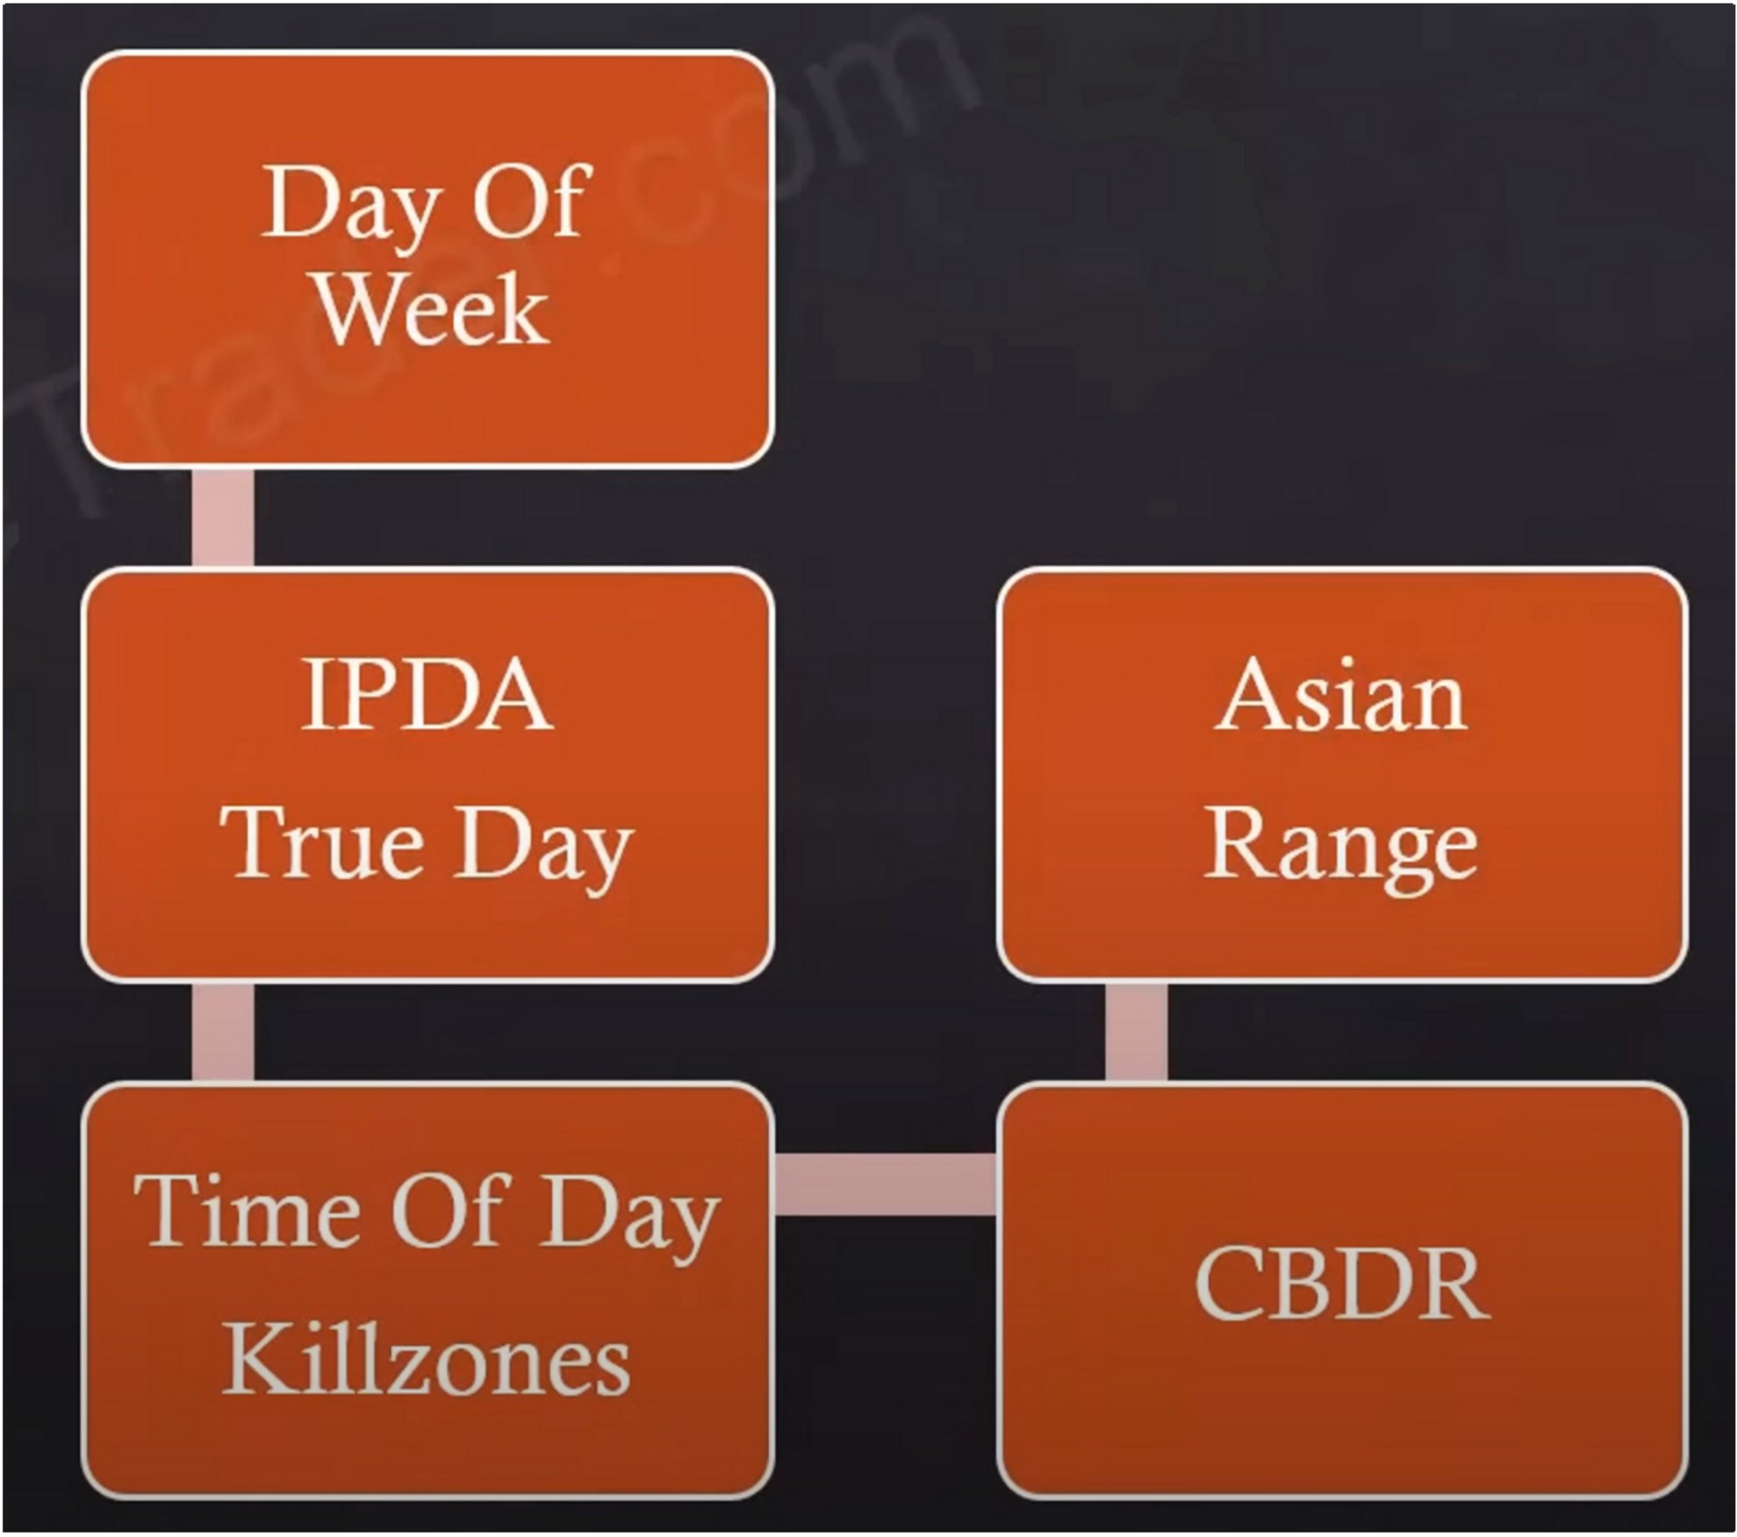

Again asian range standard deviations just like CBDR

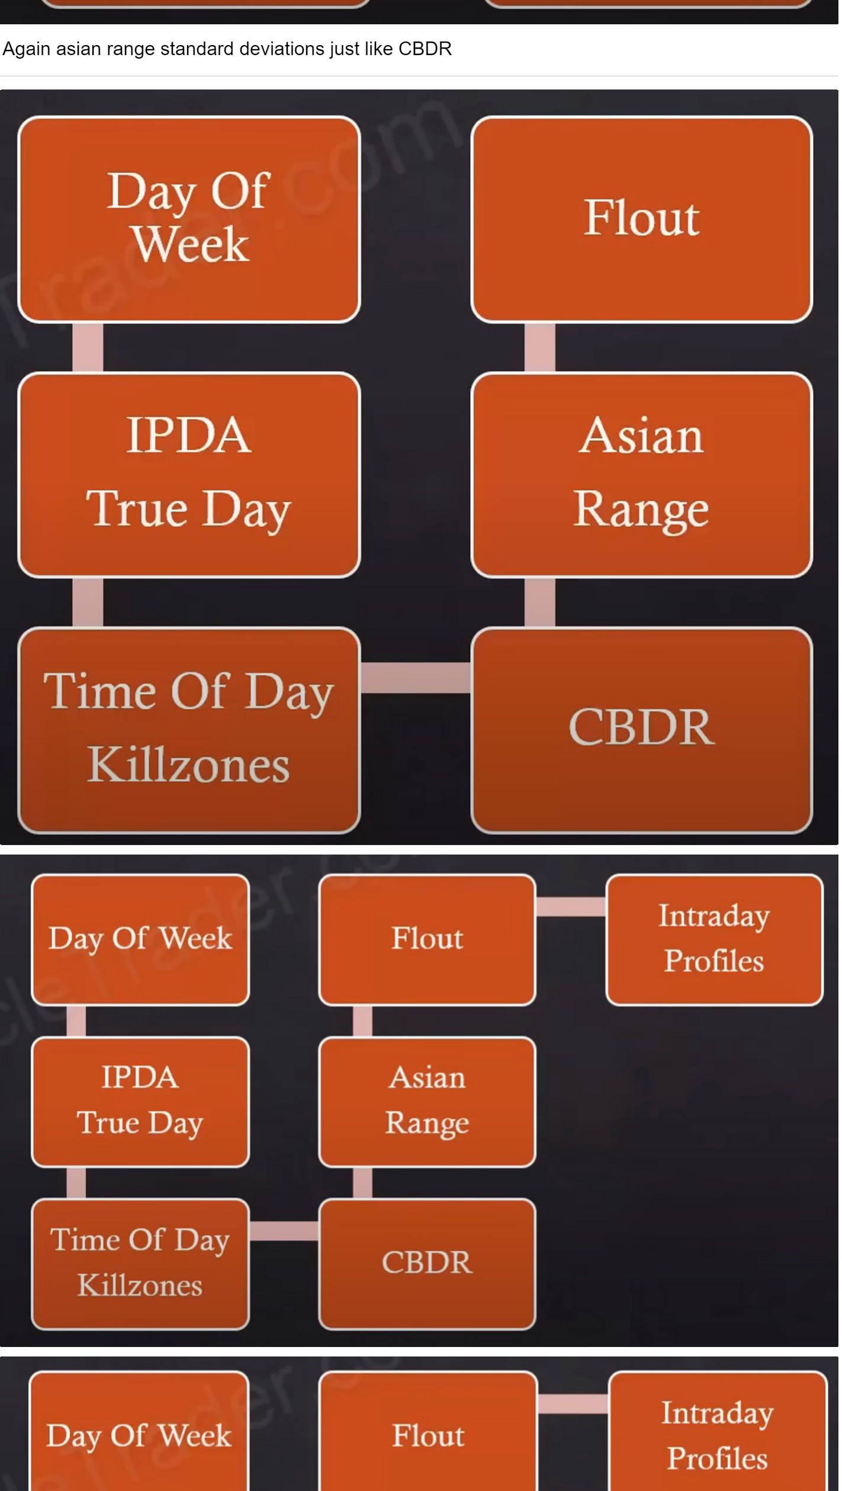

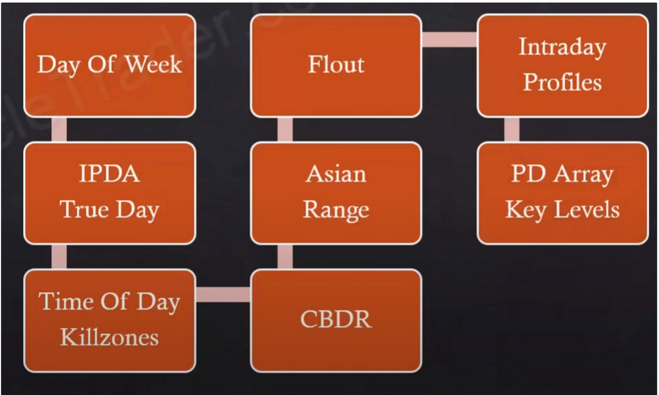

Day Of Weck

Flout

Intraday Profiles

Day Of Weck

Flout

Intraday Profiles

IPDA

True Day

Asian Range

PD Array Key Levels

IPDA

True Day

Asian Range

PD Array Key Levels

ADR

Time Of Day Killzoncs

CBDR

Time Of Day Killzoncs

ADR

Projections

CBDR

Projections

,..\''

You need to decide where youre going to go after the 4h, make it a personalised approach, which timeframe are you going to after the 4h, 1h is nice but it still has to be refined a bit more. ICT likes to go from a 4h into a 30m or 15m and then further refine it to the 5m if possible, usually ICT looks for his setups and executes on the 15m minimum, the best is to get down to the 5m

The key is that we look for a timeframe below the 4h that produces FVGs, the 1h may be muddy and the 15m may have clear FVGs. So we can select our PD arrays on the 15m as well.

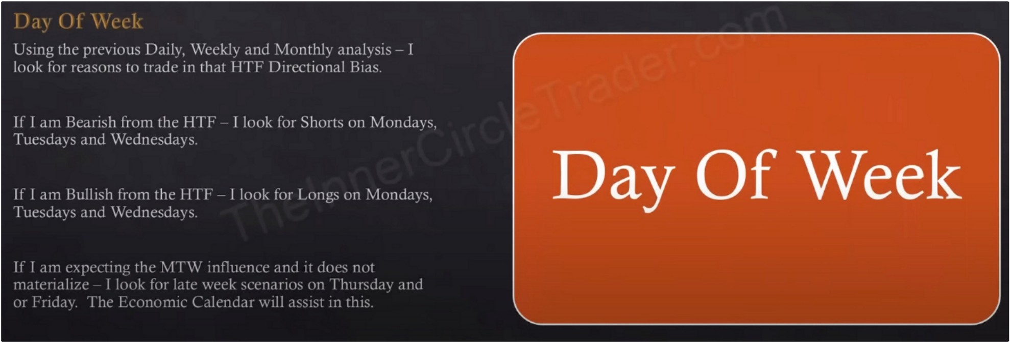

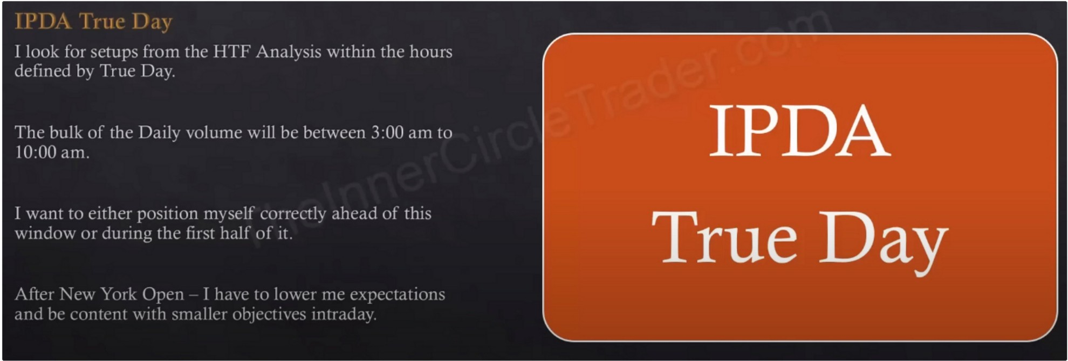

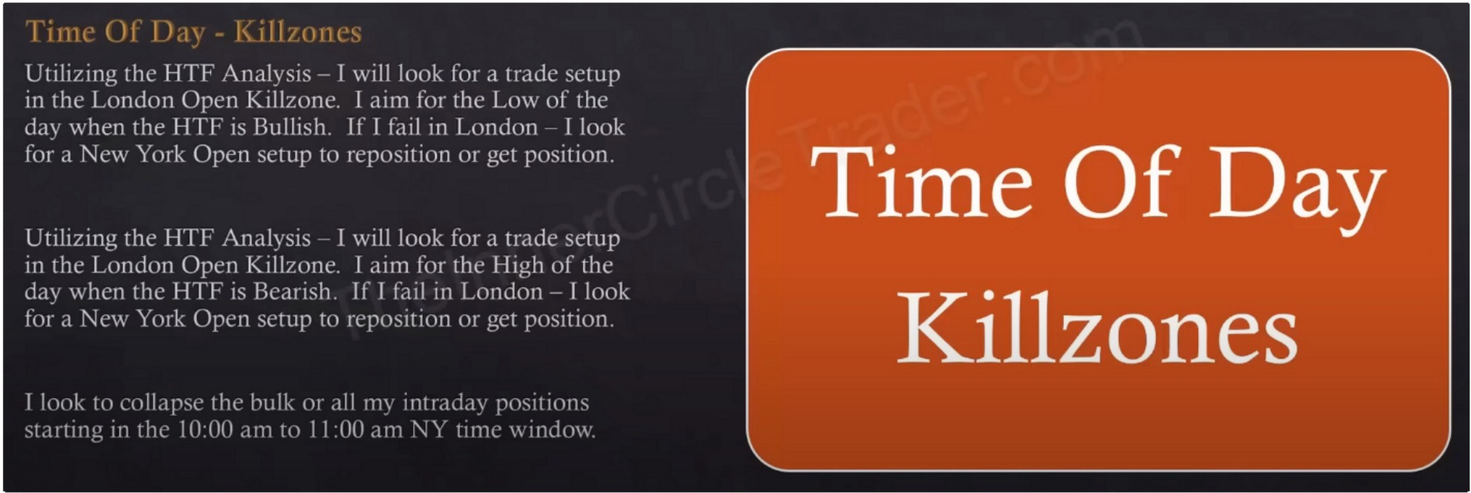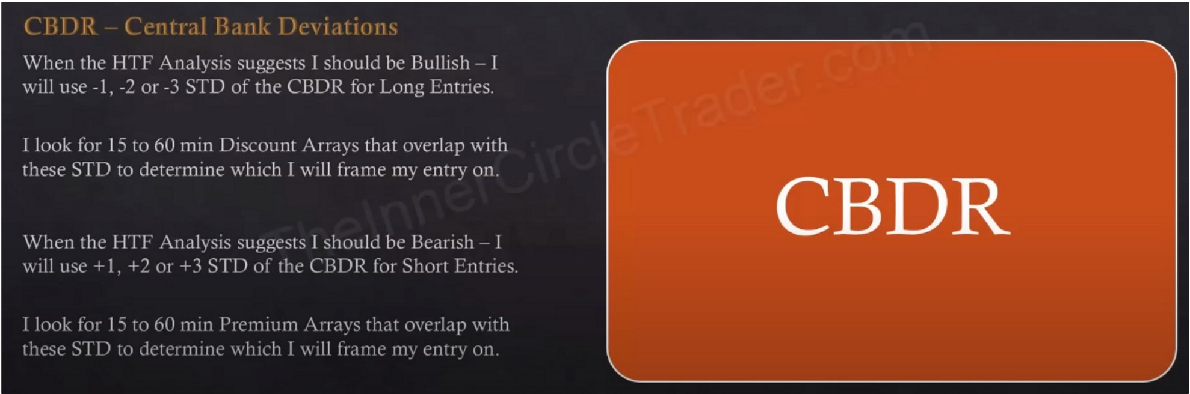

We need the STD to overlap with a PD array, thats the key, we need to blend those things together

Again, its all about the PD array matrix, if you dont use it or dont understand it then you wont be consistent

\ I : 11 I I 11 l

If 111, HTF i\n,11\sis is Rullish

bcln\\· thL' J\si,m Range High

**I will** louk to enter Longs

prdn.ibl, undn the Lm,'

II 111, 1111 ,\n.ihsrs is lk.rnsh I wrll look to ,·nt,·r Shorts

.1hove the Asi,tn R.1ngc I _ll\\ ,,,eh.:rahly ,1hu\ L' thL' I I igh

II I ,1111 llullrsh

I L'Xpect the 1\si,rn R.rnge I ligh to h,· 1,·1ested

lln cntr\ 1n ,1dd111g \ll {)PL'll pusiti(ln:-. Lnng

It I ,1rn lk,1n..;h I L'\J1l'l·t thL' ,.\ 1,111 R,lllP,l' I.()\\ tn he JL'll'"IL\i It\) l'!lll \ Ill ,tddill,!..', [ll tl\1L'tl !'lhllitllh Shtlll

**Asian Range**

I 11· I 1.1 h l\.!11'.'.l' )l:1\'l', ll!lll'- I

()(II-, 111:

l l',I )I, '.ll)] 1)\\ .1::,I) l<li lll [

'.---11) j(I (l\('IL1;1 \\ :ill

If were bullish the best scenario is to go long below the asian range low, but as long as were below the asian range high we'll still take high probability longs

If were bearish we preferably want to go short above the asian range high, but as long as were above the asian range low its still defined as a high probability short

Sometimes it will retrade to the asian high at new york open and then trade higher

When asian range projections and CBDR overlap both with a PD array youre likely going to nail the high/low of the day

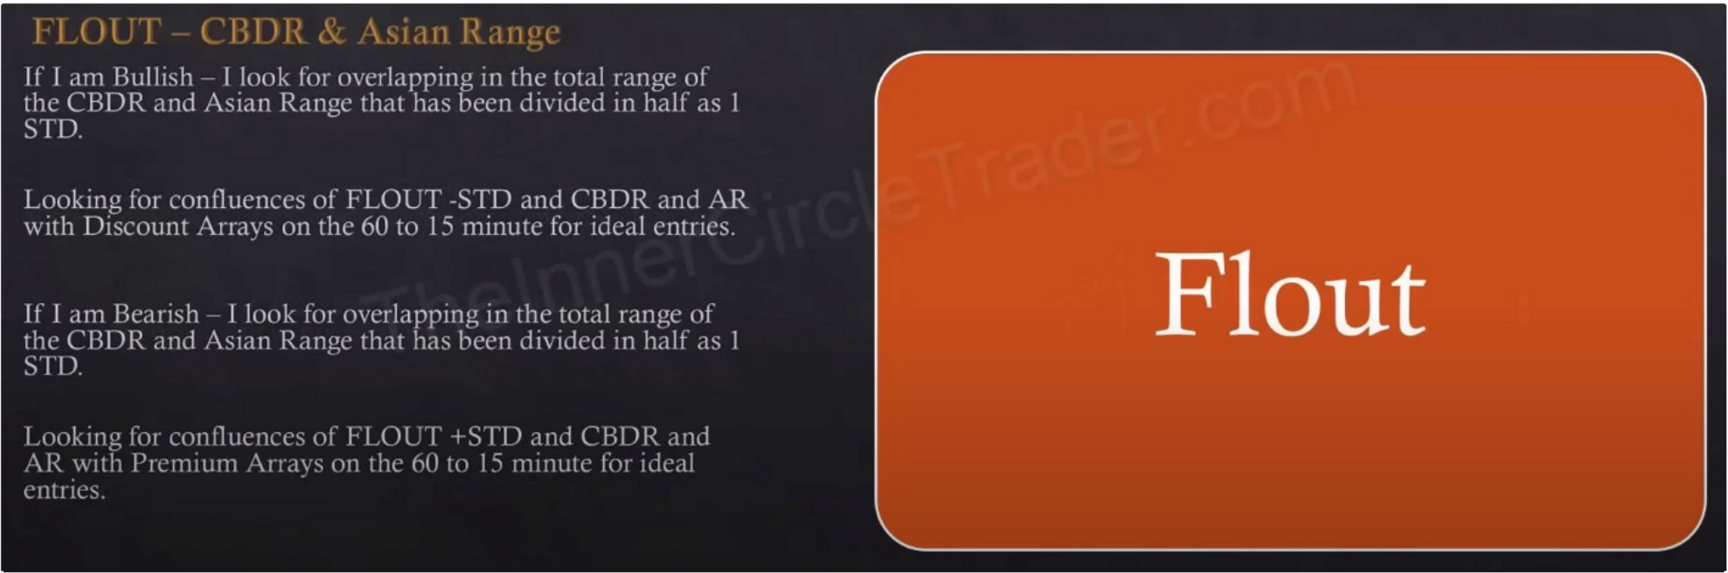

Flout

The flout is the CBDR and the asian range combined and then the half, that whole time window. The highest high and the lowest low in the form of the wicks and in the form of the bodies of the candles. Go back to the flout lesson if its not clear.

Flout can be many STD there isnt a rule based STD like theres is for CBDR or asian range, asian range can go up 1 or 2 STD and create the high or low of the day, flout can be many S

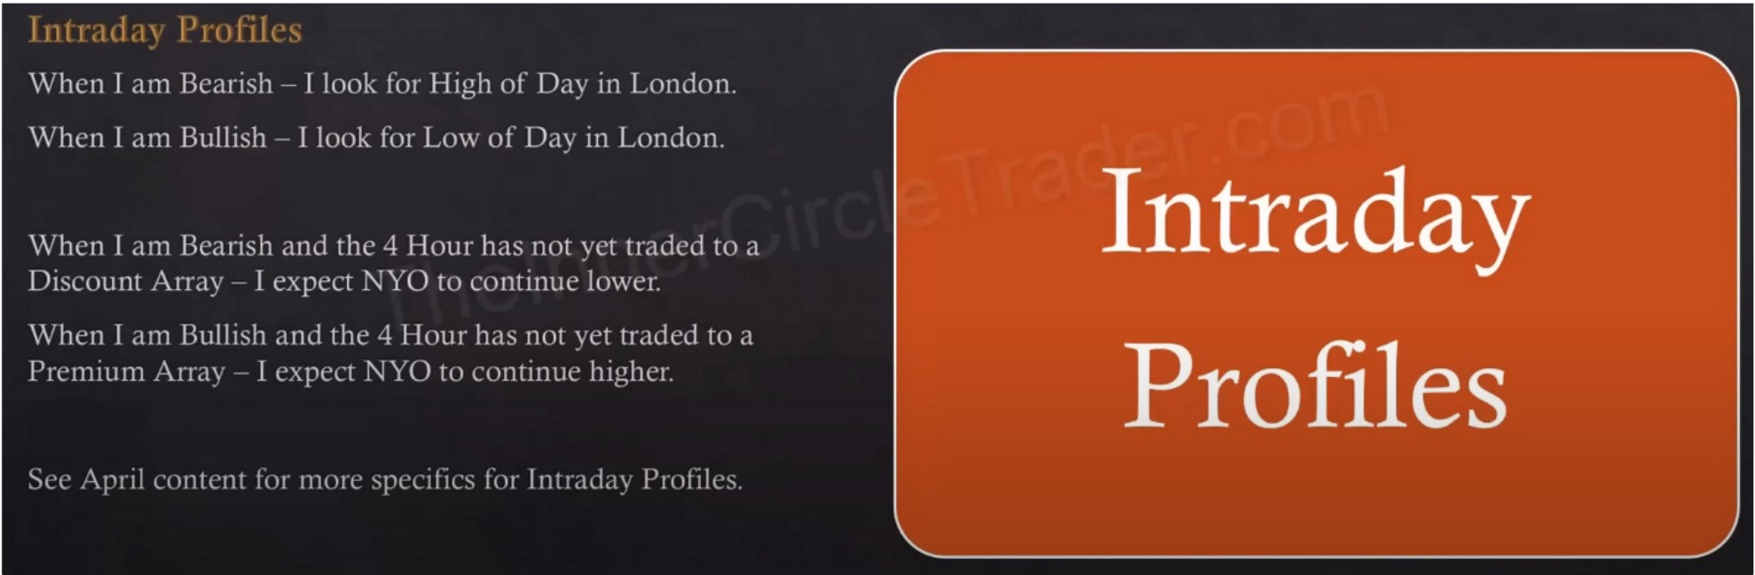

This is how we can anticipate new york reversals or continuations

As long as NYO doesnt trade into a 4h PD array we expect London and new york to be in agreement with each other and that new york will follow the **HTF** bias and momentum

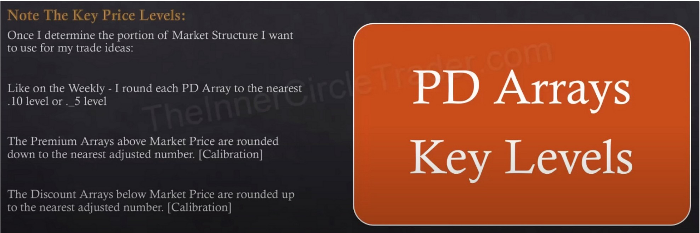

Once we determine the portion of market structure we want to use for our trade ideas, in other words we're defining a range, either we're going to operate as internal range liquidity or we're going to be working off of external range liquidity. Calibrate those levels for the PD array matrix

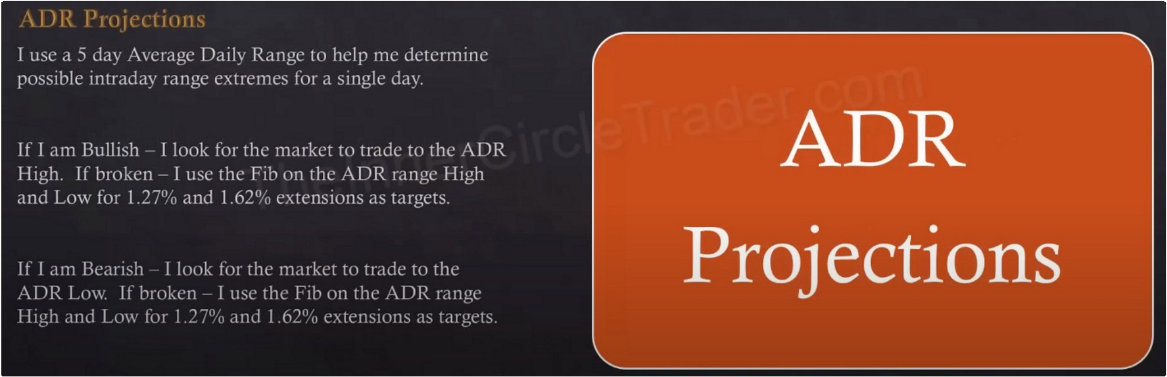

By themselves the 1.27 and 1.62 levels mean nothing, but we look for it to overlap with a PD array

lncoorporate CBDR STD and asian range STD an flout as well, and we can be very accurate and expect that we will get within 1O pips of the high or low

Projections are not absolutions, STD are assisting not guaranteeing Its the blending of all things

If we break the ADR that means we're having a big range day, how much of a big range day, refer

to the STDs and look for them to overlap with a 15m or 1h timeframe PD array Get out 1O pips before the projection

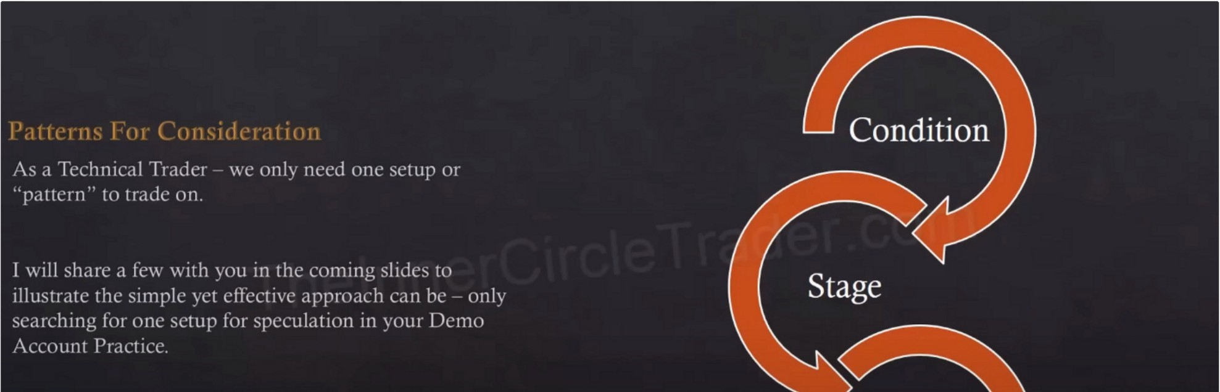

Condition: **HTF** directional bias

Stage: What sets your trade up? What does it look like? Execution, has already been talked about in the mentorship.

The main thing is, where are the setups? The entry stuff is easy

Now ICT will show us his 2 setups that he trades, he doesnt look for anything else, this is all he looks for

This is not an invitation to always do the same as ICT, we have to experiment and test things out ourselves and what suits us

You only need 1 pattern, and its very important to stick to 1 pattern.

If you try to change or do more then 1 thing in the beginning, you're not going to be able to measure consistency and you won't be able to build the confidence to stick to it.

ICT can see: ICT stingers, reflection patterns, Oro patterns

He talked about these patterns in free tutorials and on youtube

ICT can see them and let em pass, he sees them and says they could potentially happen but he does not execute on them. The thing he executes on will be explained in this teaching, these are the ones he executes on and hunts for

Dont think that you HAVE to do these patterns to be able to be succesful, theres other patterns that ICT explained that also work

Entry patterns:

ICT Bullish Pattern #1

Ive noticed that this is the setup he sometimes uses in the 2022 mentorship with the buy stop once we trade below the FVG looolll, makes so much more sense now.

This is ICTs fair value play or OTE

When OTE overlaps with a FVG a short term low and back into a bullish orderblock then you have 4 things goig for you, 4 confluences. If you have that with HTF bullishness, then if its going to go up its going to go up STRONG.

This is the criteria that works more then any other

Theres many times when it rallies up and it will retrace and there is no short term low in between and if there isnt then its not as high probability

When ICT sees this then this is what ICT wants to be trading when looking for fair value buys or in this case OTE (remember the difference between OTE/fair value/internal range liquidity setups and liquidity sweep/turtle soup/external range liquidity setups)

This is an internal range liquidity range expansion trade, so in other words it creates a range from the low at the orderblock up to the impulse swing and starts to retrace, while its retracing inside that range thats internal range liquidity, going long inside that range with the expectation that its going to expand outside of it and were going to be targeting external range liquidity

ICT Bullish Pattern #2

This is a turtle soup/external range liquidity setup, the previous one was a fair value setup A fake low, when price hovers above the discount array, we want to kill those early bulls Patience pays here, we're patient because we know what we're looking for

This is when turtle soup works

ICT Bullish Pattern #3

If you cant get that turtle soup entry, thats fine then wait for this

Wait for price to rally trough the short term high and now that short term high becomes our bullish breaker and when price comes back to that breaker that will be our entry

Price shouldnt come back down to that lower low at that stop run

There usually isnt going to be a retracement down into an orderblock below the breaker

Say this is the 4h chart, in this portion of the range here thats going to be a lower timeframe internal range liquidity or OTE, you wont see it like this but on the lower timeframe it will be an OTE and we will trade back into a lower timeframe bullish orderblock or a lower time frame discount array like a FVG, but you overlap it with that bullish breaker. So there will be a nested LTF orderblock or other discount array within that HTF breaker.

Every pattern shown here is universal, it can be seen on every single timeframe

If we see this pattern on the HTF then we start reducing it to a LTF and look at a fractal of it

Its already done its work running the stops so it wont come back to a discount array lower then the breaker

We've essentially covered 2 patterns, external range liquidity/turtle soup and the internal range liquidity which is OTE

We have a contingency plan for both patterns, its either going to be an internal range liquidity OTE fair value play, or external range liquidity run basically turtle soup. If we miss the turtle soup then we're going to be waiting for it to go to the bullish breaker, thats it. Its the same 2 patterns but just being applied in a very specific detailed way of doing it.

If we dont see price doing these 3 things/patterns then we dont do anything

If we cant see it in price then we dont touch it, if it doesnt look THIS clear in price then we DONT trade

Targeting is in the beginning of the teaching with the ADR projections

Theres no recipe for everything to be always the same, you have to blend these things and keep working, its not simple plug and play, theres too many variables. You will never be able to automate all of ICTs things it wont happen he says. You might be able to automate some parts of it but you'll never be able to automate the whole process, it wont work like that. You need to have narrative and context behind everything and thats where your brain comes in.

Now because we have 3 specific criteria were looking for, but its just knowing 2 patterns. We have a buy program a sell program and a "if we get it wrong program" to know what were looking for. A concept that gets us long and gets us short and a concept that when we miss an opportunity on one pattern we have a contingency plan, these are only for the buyside so ICT spoke a little bit ahead of himself because we havent gone trough the sellside yet

ICT Bearish Pattern #1

Ideally we take out a short term high and then trade into the FVG and bearish orderblock ICTs favourite bearish pattern

ICT Bearish Pattern #2

Everyone else will chase price but not us, we wait.

Its a turtle soup sell, but with all the things that we look for that make it a turtle soup scenario

How do you know its going to stop above that high and it will be a turtle soup? This is how, you have to know the PD array matrix of the timeframe you're looking at.

Its going to unfold during a killzone, if london is a consolidation and a news event in new york happens then its likely going to be in new york etc

Its all blending together

ICT Bearish Pattern #3

If we missed the turtle soup

The breaker has done its job, so we can expect it to hold

Dont think we'll get a OTE in this scenario all the way back to the highest sell level, because that isnt a place where price needs to trade back to. Usually its the breaker that stops it from price going that deep

Its primarliy just 2 patterns, internal range liquidity/fair value/OTE all the same thing, OR external range liquidity/turtle soup/running out stops also all the same thing

Without understanding the PD array matrix and working from the HTF to the LTF and understanding institutional orderflow you will never be consistent with these concepts, people that have only watched the free tutorials get frustrated because its lacking rule based ideas and ICT did that intentially

First thing ICT does when he opens the charts is ask himself "where are the breakers?"

Losing gives you a premium insight because you know exactly where it wants to go then, and dont fight that, losses will happen.

Gold example:

We want to drop it down into a discount

We cant trade it long when its going up on the 4h if our timeframe is looking for a discount so we have to wait for it to come lower

We drop down into a 1h chart

Only buyside was offered

If price would give up the FVG and it would go lower then the first one it would come to would be that swing high, if we enter on the FVG our stop would have to be below that level so below the high the next discount array, but since that candle that created the FVG is lower then the stop placement we will place the stop below the next discount array which is the next swing high

If we missed this opportunity we can now use the breaker to get long

Everything in the 4 teaching seems like a lot, but it really isnt, within minutes you already have an

idea

Now we have all the components to make our own trading plan, ICT gave us his trading plan Now you have everything you need

Theres no secret teaching in the future, this is everything ICT knows and does, he wishes there was more haha, but really this is it

This is what makes ICT besides some topical studies that ICT wants to talk about Its limitless